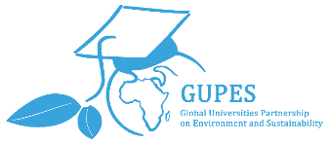
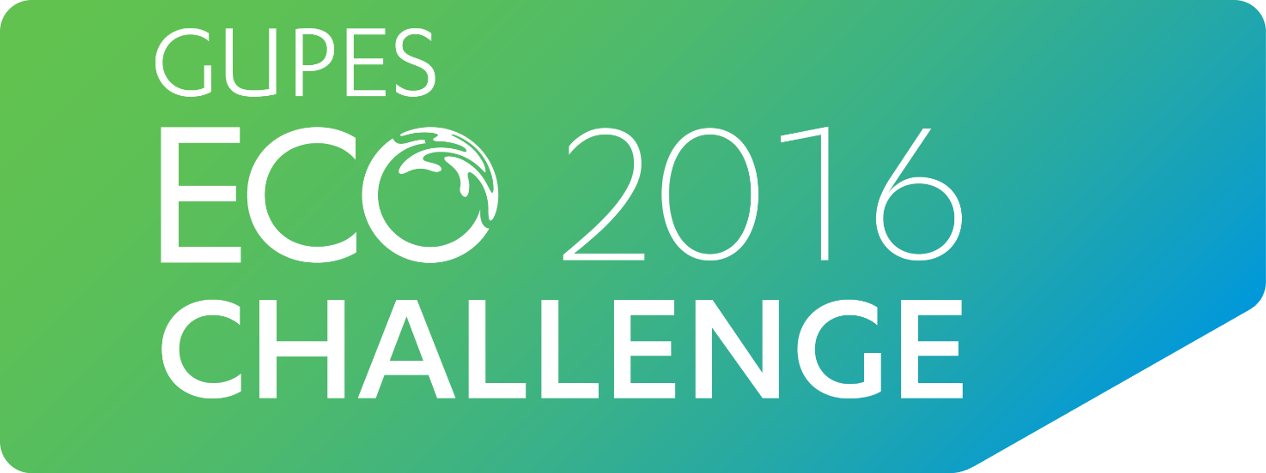

Join the GUPES Eco Challenge 2016 Competition!
Global Universities Partnership on Environment and Sustainability (GUPES) is an interactive international network of over 680 affiliated universities and together with UNEP, and the UNEP-DHI Partnership is organising the first ever GUPES Eco Challenge 2016 Competition!
This eventaims to raise awareness about the importance and interconnectivity of water and environment, as well as how it can be more sustainably managed.
What better way to do it than to play and compete in a water management game called “Aqua Republica”? So form up teams and prepare to pitch your wits against other players within the GUPES network!
Find out more information about the GUPES Eco Challenge below:
Competition period: June 1st to Aug 31st 2016
How to sign up:
- Form up teams of 3!
- Contact your university contact person <University Contact Person details>to register for the competition as a team
- Get your account from the contact person<University Contact Person details>as well as the competition dates<University competition dates>
- Play as many times as you wish during the competition dates<University competition dates>

