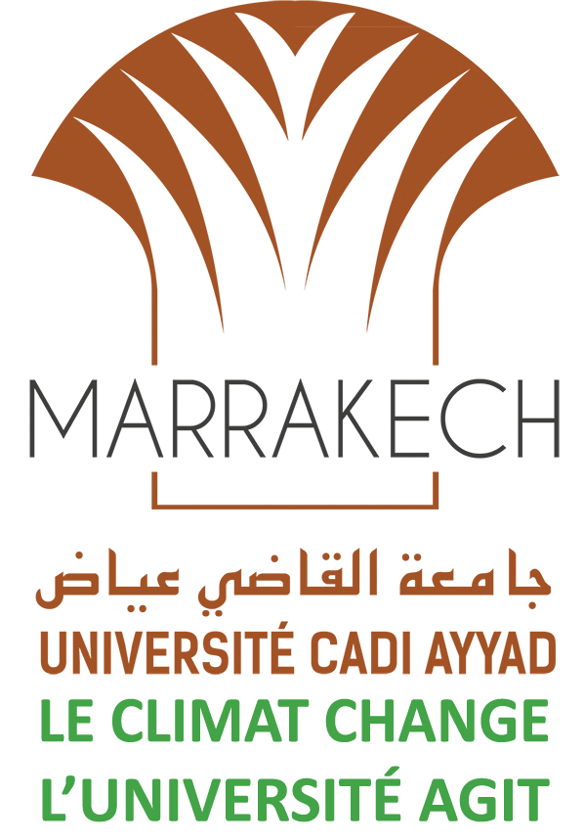

Quelques photos de l'événement

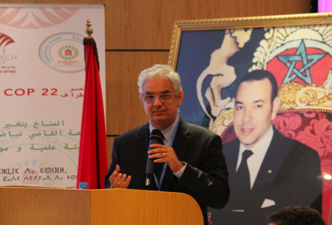 | 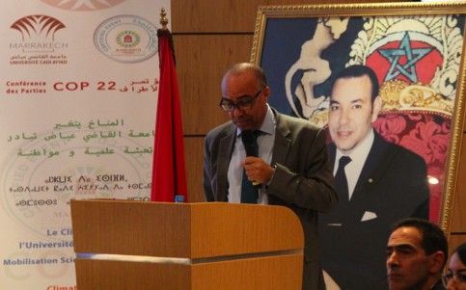 | 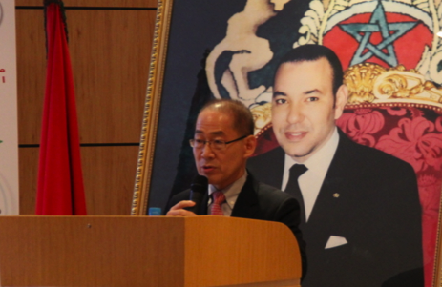
N. Baraka president of scientific committee - CoP22 | A. Miraoui Président UCAM | Dr Hoesung Lee Chair of the IPCC
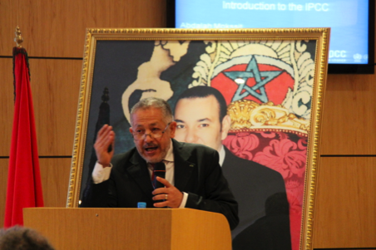 | 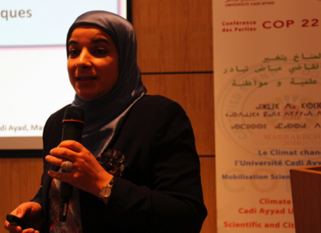 | 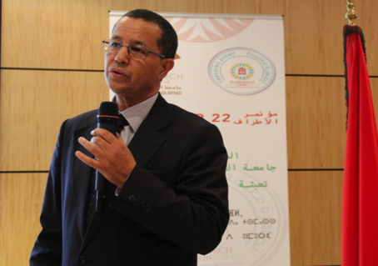
A. Mokssit Secretary of the IPCC | F. Driouech Vice President of Group I of the IPCC | M. Messouli IPCC Author
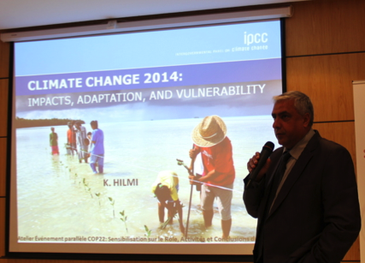 | 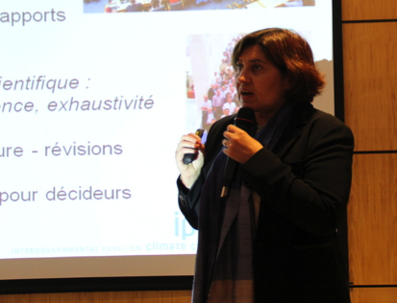 | 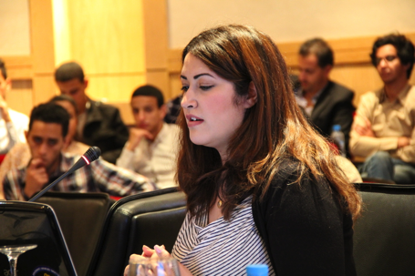
Karim Hilmi, IPCC Author | Valérie Masson-Delmotte, co-chair of IPCC WG1 | K.Kahime Phd student from UCAM, beneficiary of IPCC Scholarship

