POST-DOCTORAL GRANTS FOR RESEARCH IN THE UNITED STATES OF AMERICA
FOR THE 2021-2022 ACADEMIC YEAR
The Moroccan-American Commission for Educational and Cultural Exchange is now accepting applications for post-doctoral research grants from Moroccans who hold teaching and/or research positions in Morocco. The application deadline for the 2021-2022 year is November 15, 2020. Selected candidates may leave for the United States beginning in summer 2021. The duration of the grant is for three months. Note that the grant period must be continuous and with no interruptions.
The research Grant covers:
- Round-trip airfare
- Monthly stipend
- Settling-in allowance
- Professional allowance
- Dependents allowance
- Health insurance
The application must include:
- A completed and signed grant application form;
- Documentary proof that the applicant holds a graduate degree, preferably a Ph.D., a Doctorat d’Etat, or the equivalent;
- Evidence of an adequate level of English, for example:
- a score of at least 475 on the paper based TOEFL (Test of English as a Foreign Language); or 52 in the internet-based test (IBT); OR
- a degree from an English-language university; OR
- a university diploma certifying a major in English Studies;
- Your curriculum vitae in English, with a full list of publications and conference papers;
- A detailed description of your research project in English and your bibliography;
- An invitation letter from the American host institution (you sponsor or research partner), indicating agreement to provide facilitative assistance for you during the grant period;
- A clear, detailed action plan for the period of the grant outlining timing and goals of successive phases of the grant.
- Three letters of recommendation from colleagues or other persons able to comment on your level of commitment, your academic record and suitability of the research project;
- The approval of the director of your institution in Morocco.
NOTE: Applicants in the medical sciences must show that their project is a research project and not a technical internship. The letter of invitation from their research partner in the United States must be very clear on this point.

Important restriction: Permanent residents of the United States (holders of the “Green Card”) or Moroccan-American dual nationals are not eligible.
For Further information, please contact Program Officer Laila Meftah <l.meftah@fulbright.ma>

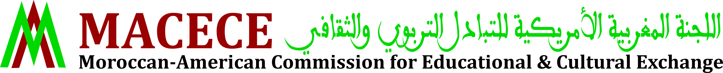
MACECE, 7 rue d'Agadir, Rabat 10010 -Morocco-
Tel: (+212) 5 37.76.41.09 & 5 37.76.04.68
Fax: (+212) 5 37-76.88.52
Website: www.macece.ma
Find us on Facebook: Fulbright Morocco

